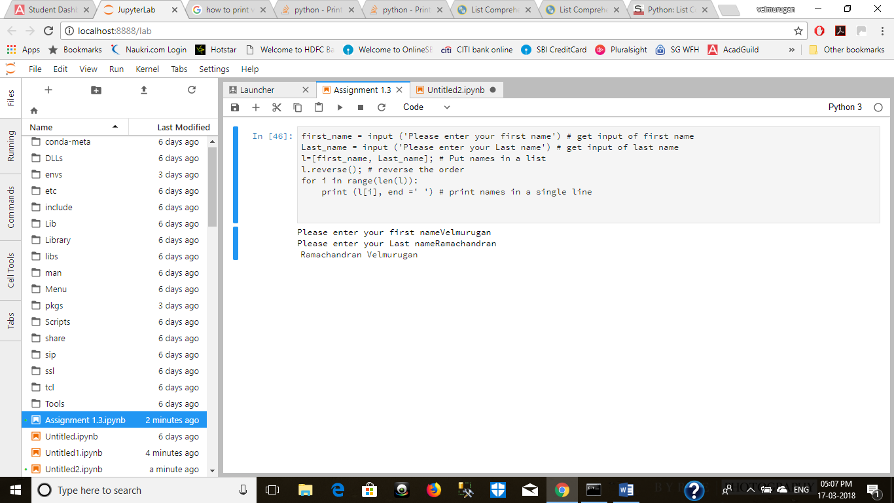

Source Code:

first_name = input ('Please enter your first name') # get input of first name

Last_name = input ('Please enter your Last name') # get input of last name

l=[first_name, Last_name]; # Put names in a list

l.reverse(); # reverse the order

for i in range(len(l)):

print (l[i], end =' ') # print names in a single line